Flight Booking App in JAVA - Servlet & JSP

***FlyAway***

*Developed by:Kopal*

# This document contains sections for:

 Project overview

 Project's core concepts

 Flow of the Application

 Agile and Scrum: User Stories from the Project

 Demonstrating product capabilities, its presentation and user interactions.

 Pushing code on Github

 Conclusions

**Project Overview:**

1. Technologies used

 Frontend - JSP, HTML, CSS Backend - JAVA Servlets Database - MySQL Application Server

- Tomcat 8.5

1. Features

 Book Flights - The user fills out flight information (date, source, destination, number of travelers). A query is made to a remote database in order to retrieve associated flights, which are then displayed to the user. User can proceed to book the flight.

 Admin - A username and password are required to access the admin dashboard. After logging in, the administrator can change his password or can insert the new flights.

**Project’s Core concepts:**

 Language: Java (Eclipse IDE)

 Concepts:

* + File Handling,
  + Collections framework,
  + Exception Handling,
  + MYSQL-workbench,
  + Recursion,
  + Sorting,
  + Flow Control.

**Flow chart of Application**

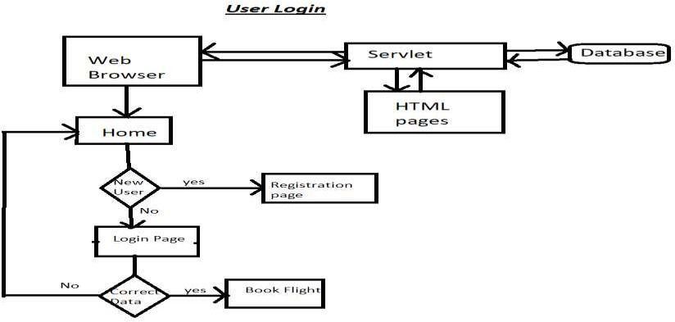

Search flights

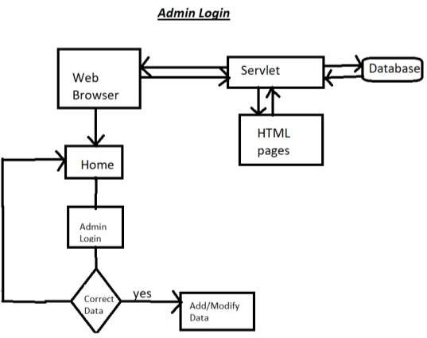

Change Password

**No**

**Agile and Scrum: Users Stories**

The project will be finished in three sprints. The following tasks are expected to be performed throughout the sprint:

⇒ Creating the application's flow

⇒ Setting up a git repository to track changes as the project develops.

⇒ Writing a Java programme to meet the project's requirements.

⇒ Putting the Java software through its paces with various types of user input

⇒ Using GitHub to push code.

***Users Stories to be covered per sprint:***

# Sprint 1

1. As a user, I want to create account on website.
2. As a user, I can login and logout.

# Sprint 2

1. As a user, I want to search flight options available to me based on date, source and destination.
2. As an administrator, I can login to website.

# Sprint 3

1. As an administrator, I can add more flights.
2. As an administrator, I can change my password.

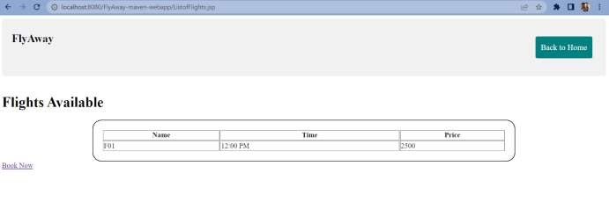

**Demonstrating product capabilities, its presentation and user interactions.**

The following sub-sections have been adjusted to showcase the project's aesthetic and user interactions in order to demonstrate the product's capabilities:

Home page:

Search for available Flights at homepage.

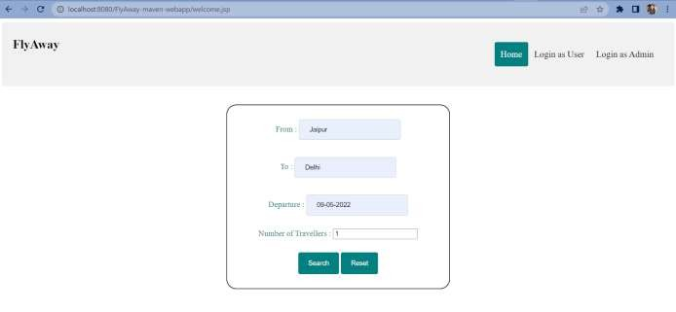

Admin Login:

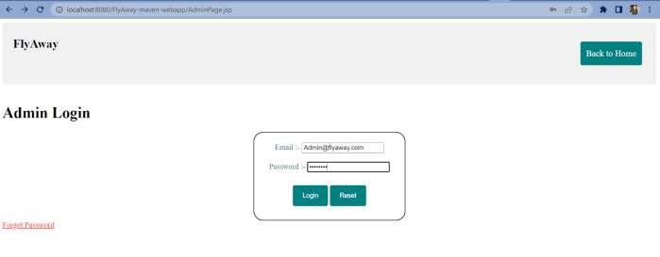

Insert New Flight as Admin

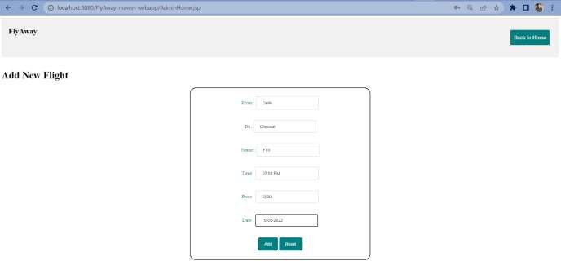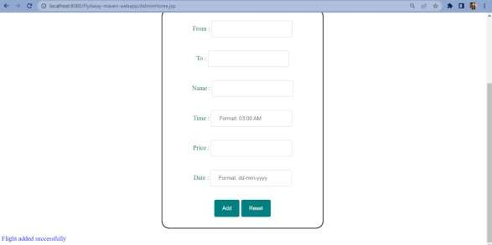

Create new Password as Adm

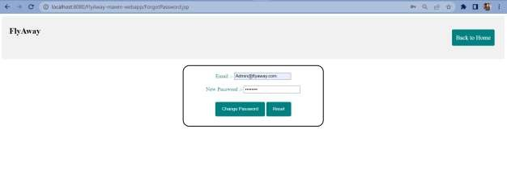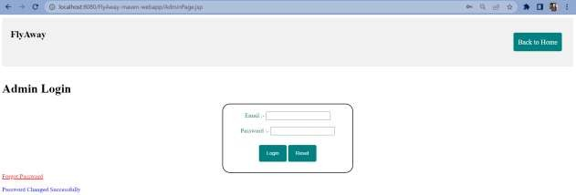

Login or Create Account as User:

1. Login

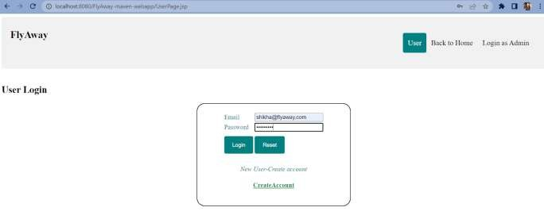

1. Create account

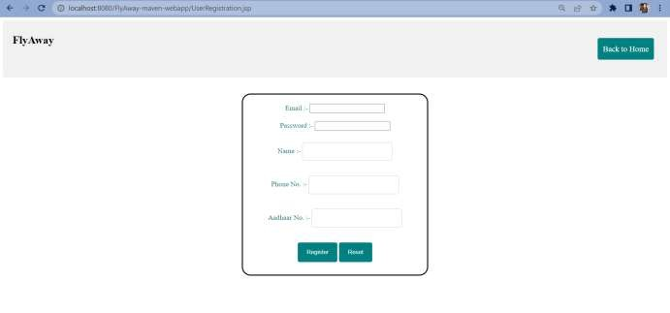

Search and Book Flight as User:

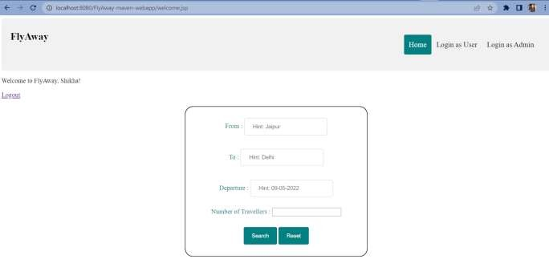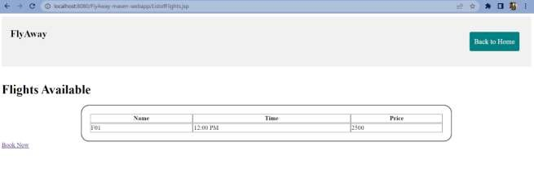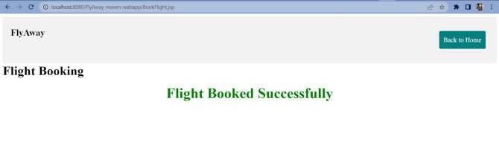

**Pushing the code to GitHub repository**

* Open your command prompt and navigate to the folder where you have created your files.

*cd <folder path>*

* Initialize repository using the following command:

*git init*

* Add all the files to your git repository using the following command:

*git add .*

* Commit the changes using the following command:

*git commit . -m <commit message>*

* Push the files to the folder you initially created using the following command:

*git push -u origin master*

**Conclusions**

An application with a sprint duration of three sprints has been developed in the programme. This application manages the *FlyAway* data. The user can create account and search or book a flight. The administrator can manipulate the flights data by logging in with an email ID and password. This application will be improved further by adding following features:

* Form/Input Validation
* Better CSS/Frontend Styles
* Modify available flights data
* Show previous flight bookings
* Ticket Payment